**Experiment Title 1.2**

**Student Name: Sahul Kumar Parida UID: 20BCS4919**

**Branch: CSE Section/Group: WM-904/B**

**Semester: 5th**

**Subject Name: Project Based Learning using Java**

**Subject Code: 20CSP-321**

**1. Aim/Overview of the practical:**

A Video Rental Inventory System The goal of this project is to design and implement a simple inventory control system for a small video rental store. Define least two classes: a class Video to model a video and a class VideoStore to model the actual store.

**2. Software/Hardware Requirements:**

# Windows

# BlueJ (Java IDE)

# JRE (Java Runtime Environment)

**3. Steps for experiment/practical/Code:**

**Video Class:**

public class Video {

String title;

boolean flag;

float rating;

public Video(){

}

public Video(String title){

flag = true;

rating = 0;

this.title = title;

}

public void setTitle(String title){

this.title = title;

}

public void beingCheckedOut(){

flag = false;

}

public void beingRetured(){

flag = true;

}

public void receiveRating(int rating){

this.rating = rating;

}

}

**VideoStore Class**:

import java.util.ArrayList;

import java.util.Objects;

public class VideoStore extends Video{

static ArrayList<Video> videos = new ArrayList<>();

static int i = 0;

public VideoStore(String title) {

super(title);

this.addVideo(title);

}

public VideoStore(){

super();

}

public void addVideo(String title){

Video video = new Video(title);

videos.add(video);

i++;

}

public void checkOut(String title){

for (Video video:

videos) {

if(video.title.equals(title)){

video.beingCheckedOut();

break;

}

}

}

public void returnVideo(String title){

for (Video video:

videos) {

if(video.title.equals(title)){

video.beingRetured();

break;

}

}

}

public void receiveRating(String title, int rating){

for (Video video :

videos) {

if (video.title.equals(title)) {

video.receiveRating(rating);

break;

}

}

}

public void listInventory(){

System.out.println("NAME AVAILABILITY STATUS RATING ");

for (Video video:

videos) {

System.out.println(video.title +" " + video.flag + " " + video.rating+" ");

}

}

}

**Main Class:**

import java.util.Scanner;

public class Main {

public static void main(String[] args) {

// write your code here

VideoStore videoStore = new VideoStore();

int c;

Scanner sc=new Scanner(System.in);

do{

System.out.println("1-> ADD VIDEO 2-> CHECKOUT VIDEO 3->RETURN VIDEO 4->RATE VIDEO 5->LIST INVENTORY 6->EXIT");

c=sc.nextInt();

switch (c) {

case 1:

System.out.println("Enter the Name of the video to add");

videoStore.addVideo(sc.next());

break;

case 2:

System.out.println("Enter the Name of the video to checkout");

videoStore.checkOut(sc.next());

System.out.println("Video checkout Out Successfully");

break;

case 3:

System.out.println("Enter the name of the video to return");

videoStore.returnVideo(sc.next());

System.out.println("Thank You for returning the video");

break;

case 4:

System.out.println("Enter the Name for which you would rate");

String name = sc.next();

System.out.println("Enter the Rating");

videoStore.receiveRating(name, sc.nextInt());

System.out.println("Rating received Successfully");

break;

case 5:

videoStore.listInventory();

break;

}

}while (c!=6);

}

}

**4. Result/Output/Writing Summary:**

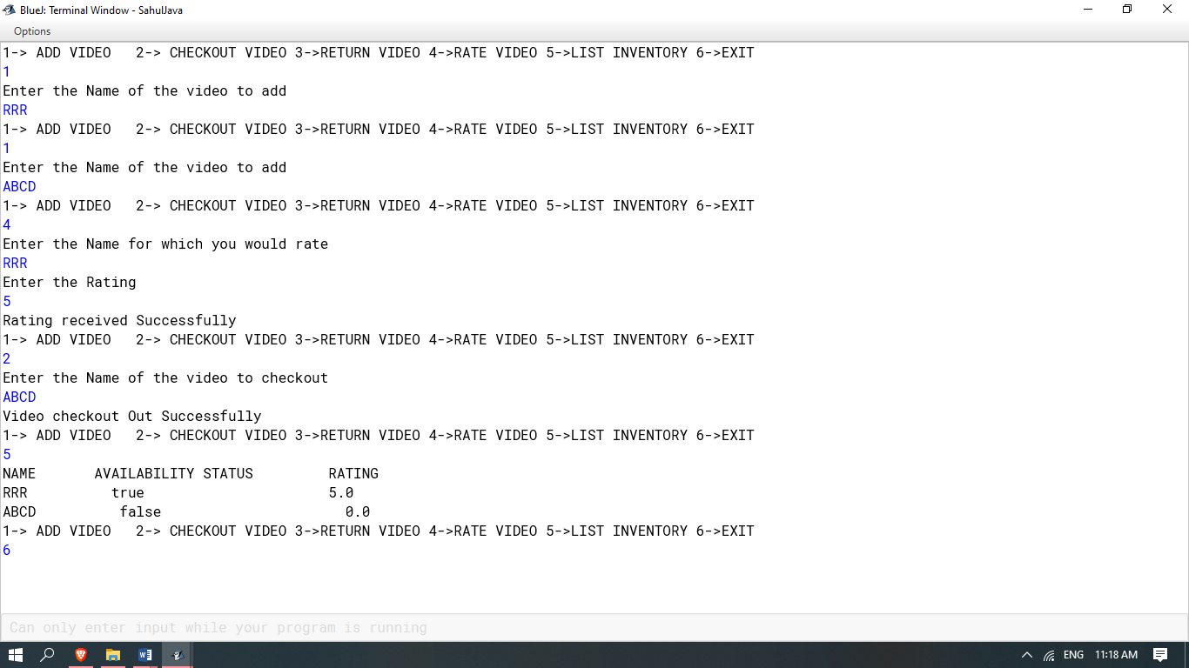

**Learning outcomes (What I have learnt):**

**1. Inheritance**

**2. Java Switch Case Statements**

**3. Object Oriented Programming**

**4. Java If-Else Statements**

**5. Java Classes**